DATE:24/10/2026
CO-2 ASSESSMENT TOOL 2 – SCENARIO BASED
COURSE CODE : DSA0308
COURSE NAME: Natural Language Processing

Reg No: 192472008 Name: C.Manoj Kumar

Q2. Morphological Parsing of Disagree, Agreement and Agreeable

1. Aim
To develop a Python program for morphological parsing of the words disagree, agreement, and agreeable by identifying prefixes, roots, suffixes, transformation categories, semantic interpretations, and normalized base forms.
2. Scenario
An AI-based sentiment analysis platform receives product reviews containing words such as disagree, agreement, and agreeable. These words share the root word agree, but their meanings and grammatical categories differ.
Morphological parsing helps the system identify the root and affixes of each word. Normalizing related words improves consistent text processing while preserving their individual meanings.
3. Algorithm
- Start the program.
- Store the input words: disagree, agreement, and agreeable.
- Identify the prefix, root word, and suffix of each word using morphological rules.
- Classify each word according to its transformation type and word class.
- Identify the semantic meaning of each word.
- Normalize the related words to the common base form agree.
- Display the original word and its morphological details in a structured format.
4. Python Program

words = {
"disagree": {
"prefix": "dis-",
"root": "agree",
"suffix": "None",
"transformation": "Prefix derivation",
"word_class": "Verb",
"meaning": "To have a different opinion or not agree",
"normalized": "agree"
},
"agreement": {
"prefix": "None",
"root": "agree",
"suffix": "-ment",
"transformation": "Suffix derivation",
"word_class": "Noun",
"meaning": "The state or result of agreeing",
"normalized": "agree"
},
"agreeable": {
"prefix": "None",
"root": "agree",
"suffix": "-able",
"transformation": "Suffix derivation",
"word_class": "Adjective",
"meaning": "Pleasant or acceptable",
"normalized": "agree"
}
}

print("MORPHOLOGICAL PARSING REPORT")

for word, details in words.items():
print("\nOriginal Word:", word)
print("Prefix:", details["prefix"])
print("Root:", details["root"])
print("Suffix:", details["suffix"])
print("Transformation:", details["transformation"])
print("Word Class:", details["word_class"])
print("Semantic Interpretation:", details["meaning"])
print("Normalized Base Form:", details["normalized"])

5. Sample Input and Output

Input:
disagree
agreement
agreeable
Output:
MORPHOLOGICAL PARSING REPORT
Original Word: disagree
Prefix: dis-
Root: agree
Suffix: None
Transformation: Prefix derivation
Word Class: Verb
Semantic Interpretation: To have a different opinion or not agree
Normalized Base Form: agree

Original Word: agreement
Prefix: None
Root: agree
Suffix: -ment
Transformation: Suffix derivation
Word Class: Noun
Semantic Interpretation: The state or result of agreeing
Normalized Base Form: agree

Original Word: agreeable
Prefix: None
Root: agree
Suffix: -able
Transformation: Suffix derivation
Word Class: Adjective
Semantic Interpretation: Pleasant or acceptable
Normalized Base Form: agree

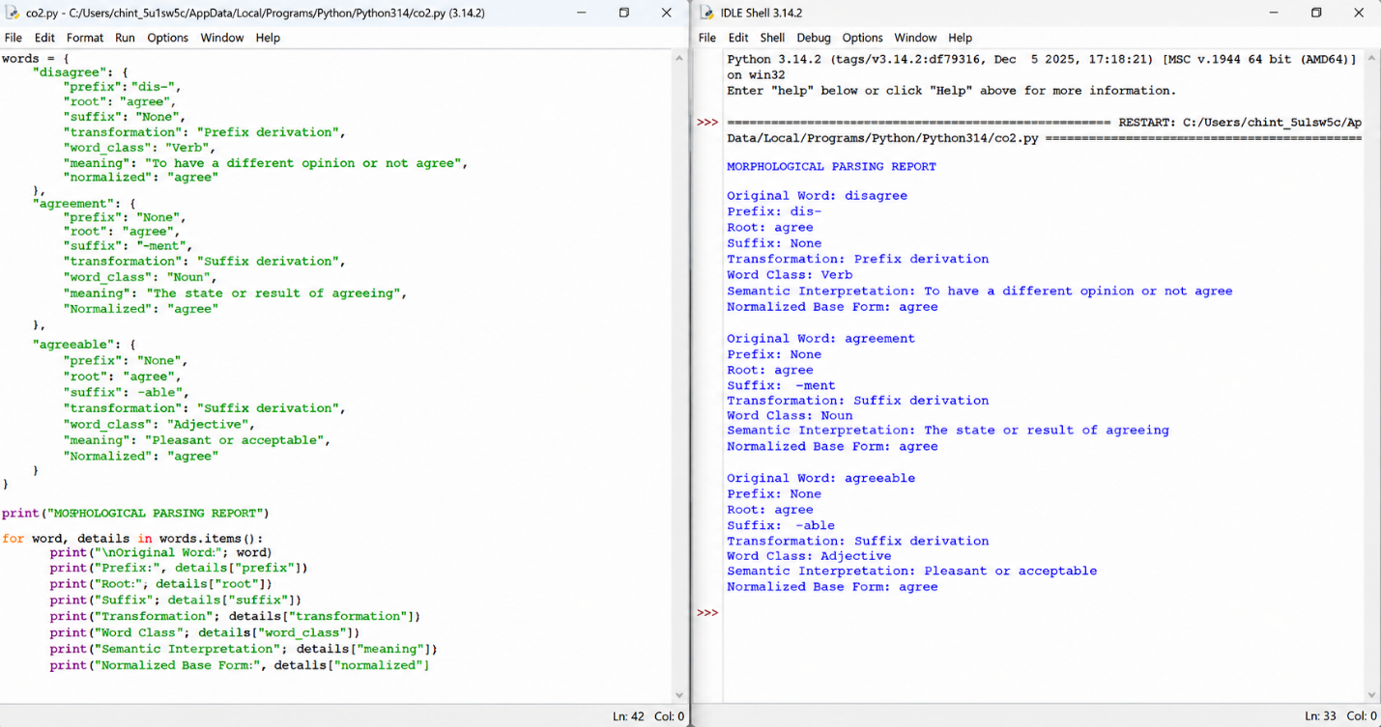
6. Explanation / Morphological Analysis

Original word | Prefix | Root | Suffix | Word class
disagree | dis- | agree | None | Verb
agreement | None | agree | -ment | Noun
agreeable | None | agree | -able | Adjective
Semantic interpretation:
- Disagree: The prefix dis- expresses opposition or negation. Therefore, disagree means to have a different opinion.
- Agreement: The suffix -ment forms a noun referring to the state or result of agreeing.
- Agreeable: The suffix -able forms an adjective meaning pleasant or acceptable.
Normalization: All three words contain the root agree, so the program maps them to the common normalized representation agree. Their original forms and meanings are retained because they do not mean exactly the same thing.
This method helps sentiment analysis systems recognize related word forms without treating their meanings as identical.
7. Result
Thus, the Python program successfully identifies the prefix, root, suffix, transformation category, word class, semantic interpretation, and normalized base form of disagree, agreement, and agreeable.

Q3. Morphology-Based Normalization of Govern, Government and Governance
1. Aim
To develop a Python program for morphology-based normalization of govern, government, and governance by identifying roots, derivational suffixes, derivational levels, and common lexical representations for topic modeling and document clustering.
2. Scenario
A news aggregation system processes documents containing words such as govern, government, and governance. These words are related, but they have different grammatical forms and meanings.
Morphological normalization identifies their common root and maps them to a shared lexical representation. This helps the system group related documents and improve topic modeling and clustering.
3. Algorithm
- Start the program.
- Store the input words: govern, government, and governance.
- Identify the root word of each input.
- Detect the derivational suffix, if present.
- Determine the word class and derivational level.
- Normalize all three words to the common lexical representation govern.
- Display the original word, root, suffix, derivational hierarchy, and normalized representation.
- Use the normalized words for topic modeling and document clustering.
- Stop the program.

4. Python Program

words = {
"govern": {
"root": "govern",
"affix": "None",
"word_class": "Verb",
"level": 0,
"hierarchy": "Base form",
"normalized": "govern"
},
"government": {
"root": "govern",
"affix": "-ment",
"word_class": "Noun",
"level": 1,
"hierarchy": "govern -> government",
"normalized": "govern"
},
"governance": {
"root": "govern",
"affix": "-ance",
"word_class": "Noun",
"level": 1,
"hierarchy": "govern -> governance",
"normalized": "govern"
}
}

print("MORPHOLOGY-BASED NORMALIZATION REPORT")

for word, details in words.items():
print("\nOriginal Word:", word)
print("Root:", details["root"])
print("Derivational Affix:", details["affix"])
print("Word Class:", details["word_class"])
print("Derivational Level:", details["level"])
print("Derivational Hierarchy:", details["hierarchy"])
print("Normalized Representation:", details["normalized"])

5. Sample Input and Output
Input:
govern
government
governance

Output:
MORPHOLOGY-BASED NORMALIZATION REPORT

Original Word: govern
Root: govern
Derivational Affix: None
Word Class: Verb
Derivational Level: 0
Derivational Hierarchy: Base form
Normalized Representation: govern

Original Word: government
Root: govern
Derivational Affix: -ment
Word Class: Noun
Derivational Level: 1
Derivational Hierarchy: govern -> government
Normalized Representation: govern

Original Word: governance
Root: govern
Derivational Affix: -ance
Word Class: Noun
Derivational Level: 1
Derivational Hierarchy: govern -> governance
Normalized Representation: govern

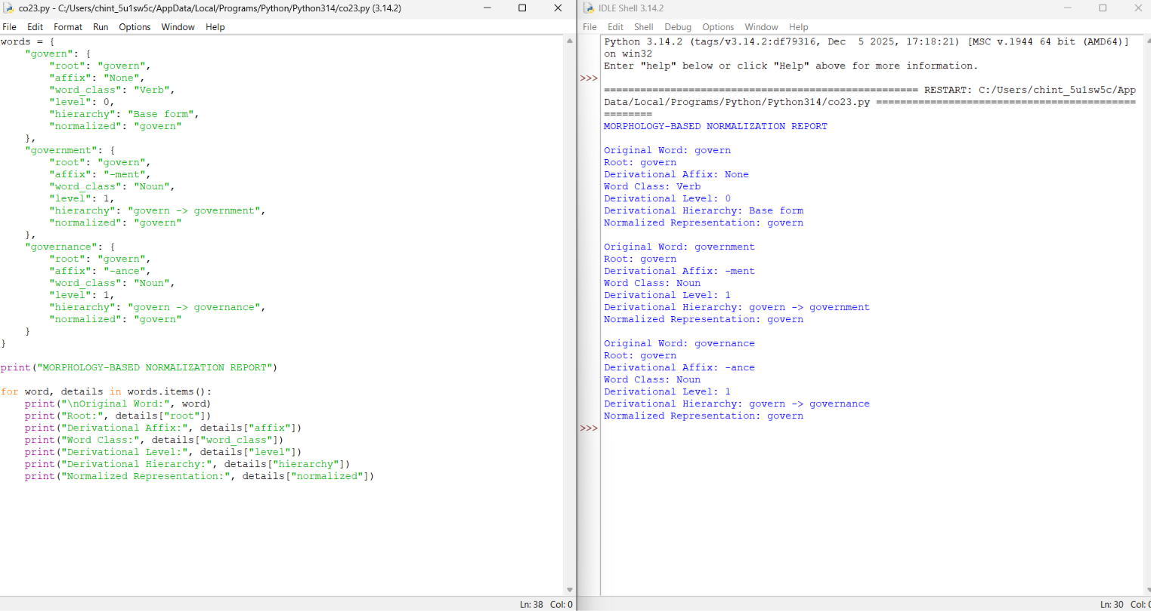

6. Explanation / Morphological Analysis

Original word | Root | Suffix | Word class | Derivational level
govern | govern | None | Verb | 0
government | govern | -ment | Noun | 1
governance | govern | -ance | Noun | 1
Morphological interpretation:
- Govern: This is the base verb. It refers to directing or controlling a country, organization, or group.
- Government: The suffix -ment forms a noun referring to the governing authority or system.
- Governance: The suffix -ance forms a noun referring to the process, manner, or system of governing.
Derivational hierarchy:
- govern → Base form
- govern + -ment → government
- govern + -ance → governance
The derivational level is represented as 0 for the base form and 1 for each word formed by one derivational step from the root.
Normalization: The program maps all three words to the common lexical representation govern. This makes it easier to group related terms when analyzing news articles.
Application in topic modeling and document clustering:
- Topic modeling: Related terms can be mapped to a common representation to help identify topics about governing and public administration.
- Document clustering: News articles containing these related words can be grouped together more easily.
- Lexical standardization: Different word forms are represented consistently, reducing variation during text processing.
The original words should still be retained because government and governance have different meanings even though they share a root.
7. Result
Thus, the Python program successfully identifies the root, derivational suffix, word class, derivational level, and normalized representation of govern, government, and governance. The normalized output supports consistent lexical processing for topic modeling and document clustering.

